Business Question and Visualization Report

Date | 21-sep-2026
Team ID | MCA(Master of Computer Application)
Project Name | Online Learning Engagement and Student Performance Analysis
Maximum Marks | 4 Marks

Visualization development refers to the process of creating graphical representations of data to facilitate understanding, analysis, and decision-making. The goal is to transform complex datasets into visual formats that are easy to interpret, enabling users to gain insights and make informed decisions. This process is commonly associated with data visualization tools and platforms, and it plays a crucial role in business intelligence, analytics, and reporting.

Business Questions and Visualisation
The following business questions guided the creation of the KPIs, charts, and interactive elements in the Power BI dashboard for the Online Learning Engagement and Student Performance Analysis project.

- What is the overall pass rate and dropout rate among students?
- Visualization: KPI cards showing Pass Rate and Dropout Rate.

- Screenshot of visualisation:
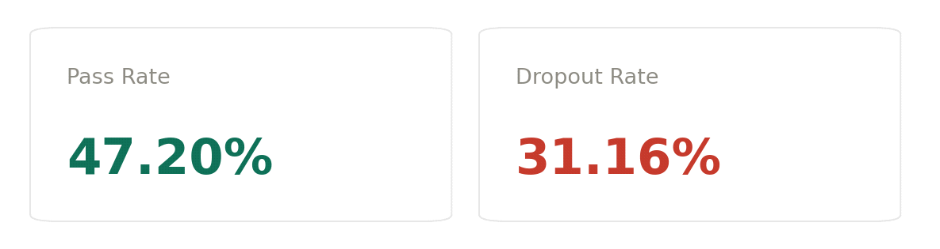

- How does student engagement level relate to average academic score?
- Visualization: Bar chart comparing Average Score across Low, Medium, and High engagement levels.

- Screenshot of visualisation: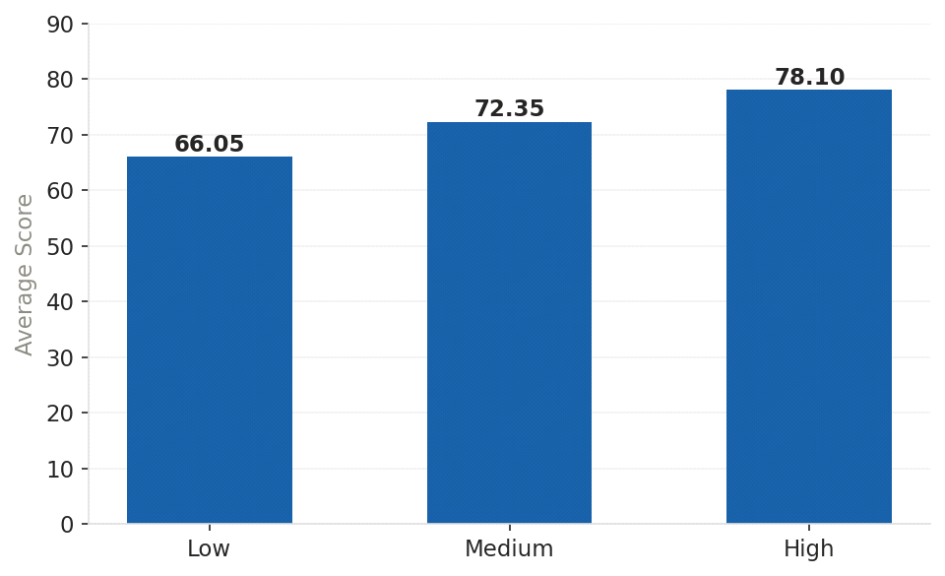

3.Which regions have the highest number of students and the highest average score?
- Visualization: Horizontal bar chart of Total Students and Average Score by Region.
- Screenshot of visualisation:
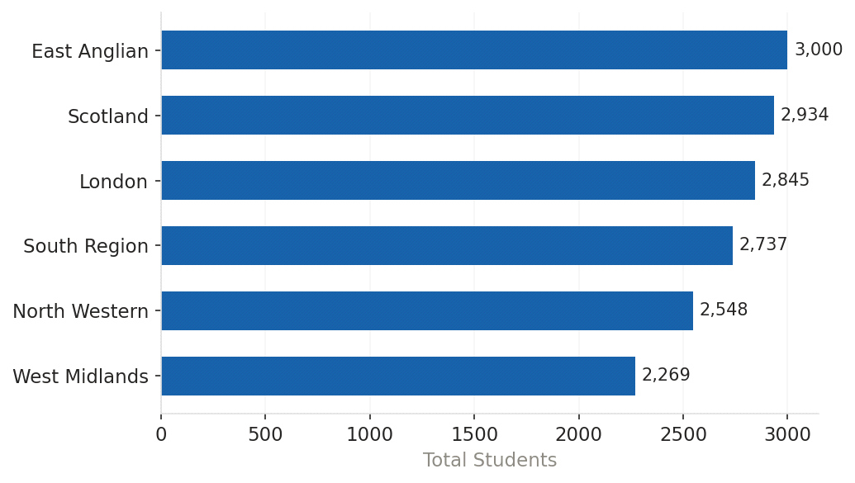

4.What proportion of students fall into each dropout risk level?
- Visualization: Donut chart showing the distribution of students across Low, Medium, High, and Very High Risk levels.
- Screenshot of visualisation:
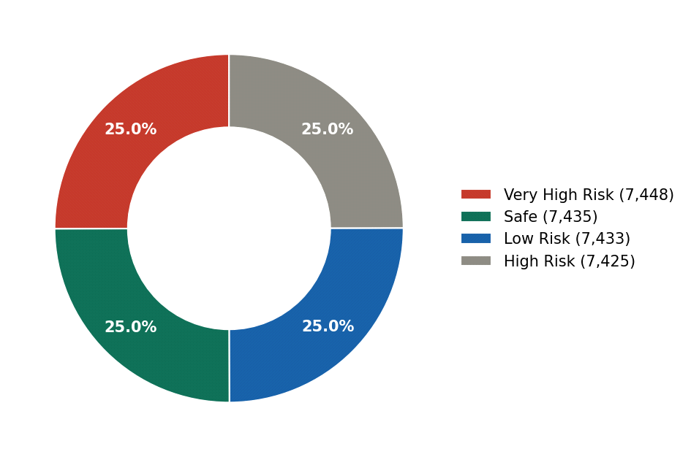

5.How does platform engagement (total clicks) relate to average score across click ranges?
- Visualization: Line chart of Average Score across click bands (0–500, 500–1000, 1000–2000, 2000–3000, 3000+).
- Screenshot of visualisation:
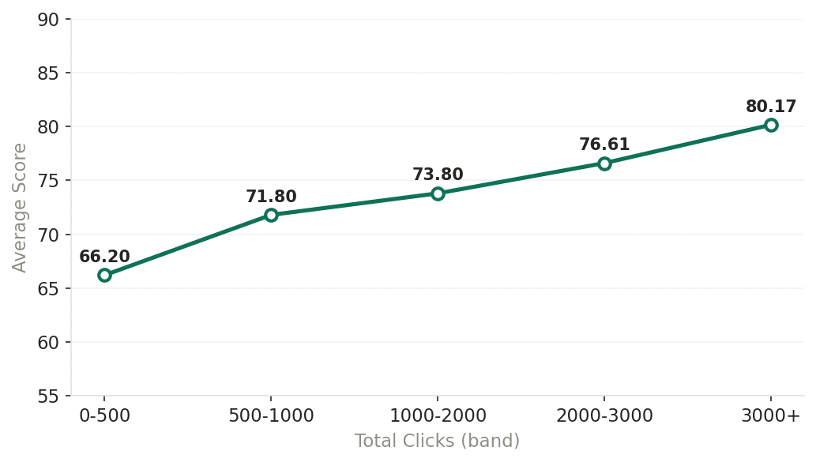

6.What is the distribution of final outcomes (Pass, Fail, Withdrawn, Distinction)?
- Visualization: Pie chart showing the breakdown of Final Result categories.
- Screenshot of visualisation:
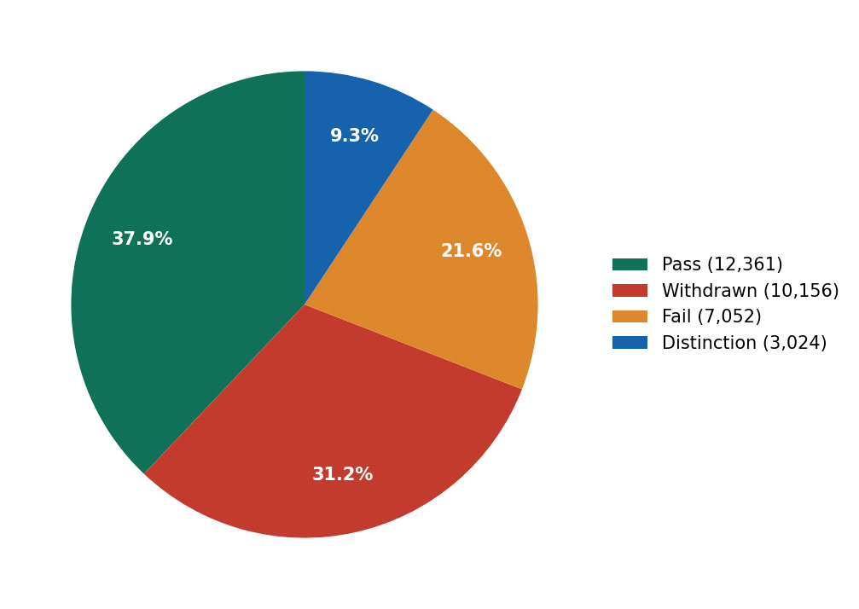

7.Which factors contribute most to student dropout?
- Visualization: AI-powered Decomposition Tree analyzing Dropout Rate by engagement level, performance level, and region.
- Screenshot of visualisation:
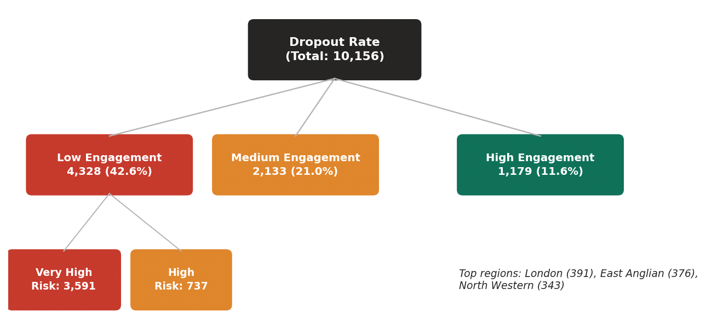

8.How does average score vary by students' highest prior education level?
- Visualization: Bar chart comparing Average Score across highest_education categories.
- Screenshot of visualisation:
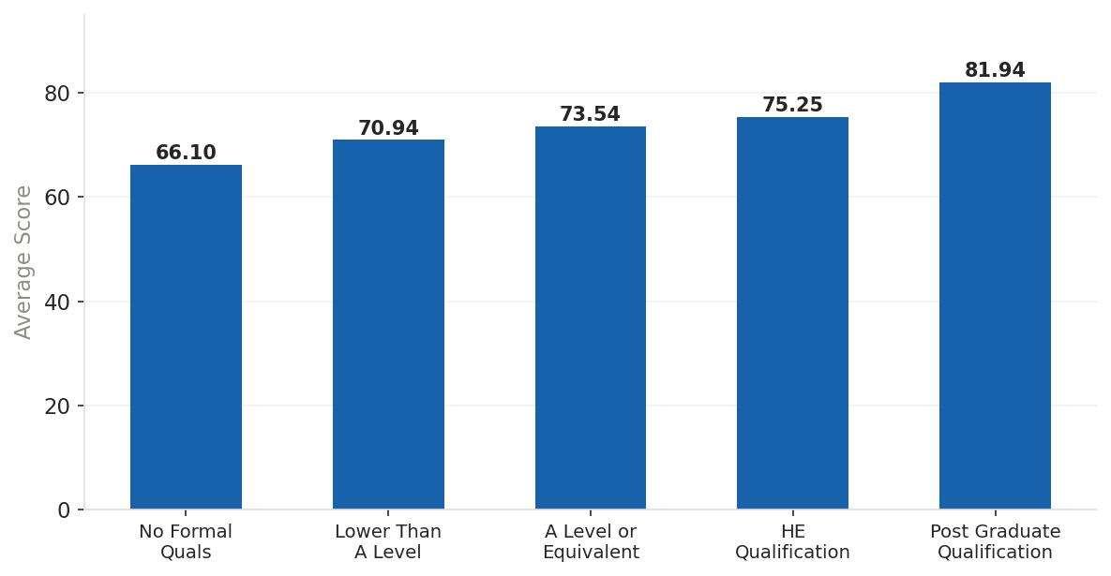

9.How do dropout rates differ between male and female students?
- Visualization: Bar chart comparing Dropout Rate by Gender, filterable via the Gender slicer.
- Screenshot of visualisation:
